Python – Full Stack Assignment
(LAB EXERCISE)

1.Write a simple "Hello World" program in two different programming languages of your choice. Compare the structure and syntax:

..\..\..\task\name.c

2. Research different types of internet connections (e.g., broadband, fiber, satellite) and list their pros and cons.
Ans: Fiber internet Pros: The fastest and most reliable connection, with speeds up to 10 Gbps. Cons: Often the most expensive option and not as widely available as cable or DSL.
-Cable internet Pros: High speeds (up to 1 Gbps) suitable for streaming and business, and widely available in urban and sub urban areas. Cons: Speeds can slow down during peak usage hours due to shared bandwidth.
-DSL (Digital Subscriber Line) Pros: Moderately priced and suitable for general use, with speeds up to 100 Mbps. It is widely available in many areas. Cons: Slower than cable and fiber, and speeds can vary depending on the distance from the provider's central office.
-Satellite internet Pros: Provides internet access to remote or rural locations where other options are not available. Cons: Slower speeds, higher latency, and is susceptible to weather-related disruptions.
-Fixed wireless Pros: Can offer high speeds (up to 1.1 Gbps) and is a good option for areas with clear line-of-sight to a transmission tower. Cons: Prone to weather disruptions and may have limited availability.
3. Identify and explain three common application security vulnerabilities. Suggest possible solutions.
Ans: Three common application security vulnerabilities are injection attacks (like SQL injection), broken authentication, and security misconfigurations.
1.Injection attacks solution : -Use prepared statements and parameterized queries. -Perform strong input validation to reject any data that doesn't meet expected formats. -Enforce output encoding to properly format data before it is displayed in a user interface.
2.broken authentication solution : -Enforce multi-factor authentication. -Implement a strong password policy that includes complexity requirements and periodic changes. -Ensure secure session management with secure cookies and by invalidating sessions after a period of inactivity.
3.security misconfigurations : -Remove unnecessary features, services, and accounts, especially default ones. -Regularly patch and update all components, including the operating system, framework, and libraries. -Ensure security settings are properly configured and security headers are set to secure values.
4. Identify and classify 5 applications you use daily as either system software or application software.
Ans: Applications we use daily, classified as either system software or application software: Google Chrome (Application), Google Docs (Application), Windows 11 (System), Zoom (Application), and a PDF reader (Application).
5. Write a report on the various types of application software and how they improve productivity.
Ans: Application software includes a wide range of programs that help users perform specific tasks, such as word processors, spreadsheet programs, databases, and graphic design tools, -They improve productivity by automating repetitive tasks, streamlining workflows, enabling real-time collaboration, and providing data analytics for better decision-making.
6. Research and create a diagram of how data is transmitted from a client to a server over the internet.
Ans:
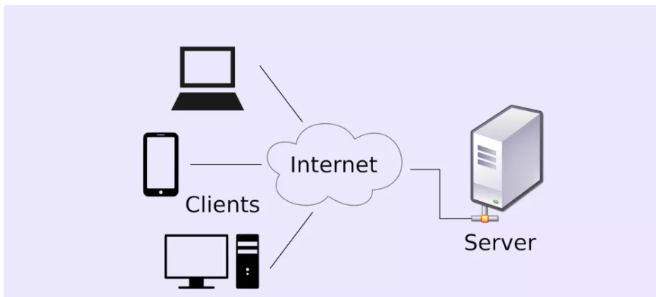

7. Design a simple HTTP client-server communication in any language.
Ans:
#include <stdio.h>

int main() {
// 1. Client sends a request
printf("CLIENT: GET /index.html HTTP/1.1\n");
printf("CLIENT: Host: www.google.com\n\n");

// 2. Server sends a response
printf("SERVER: HTTP/1.1 200 OK\n");
printf("SERVER: Content-Type: text/html\n");
printf("SERVER: Body: <html>Hello!</html>\n");

return 0;
}

8. Design a basic three-tier software architecture diagram for a web application.
Ans:
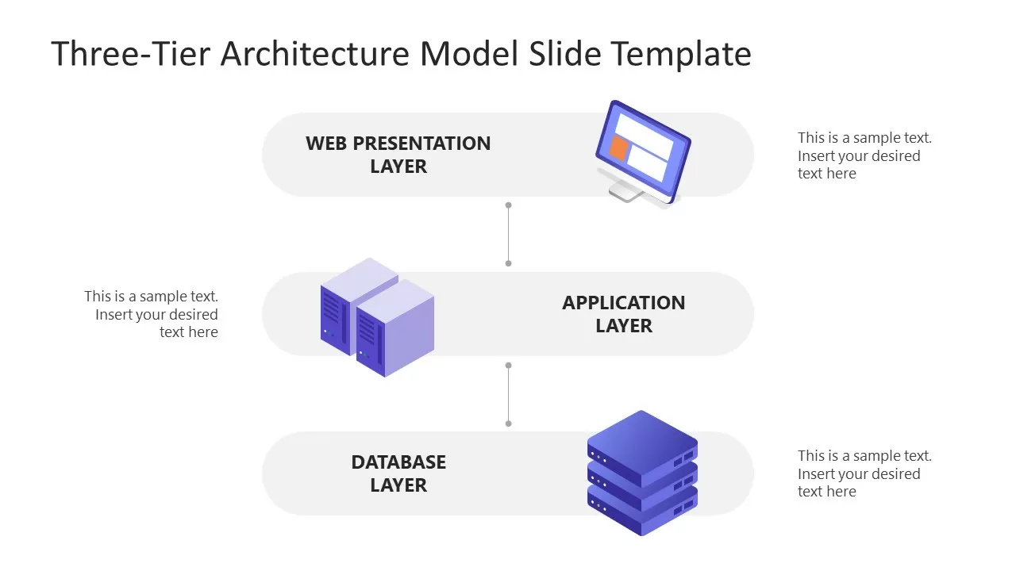

9. Create a case study on the functionality of the presentation, business logic, and data access layers of a given software system.
Ans:
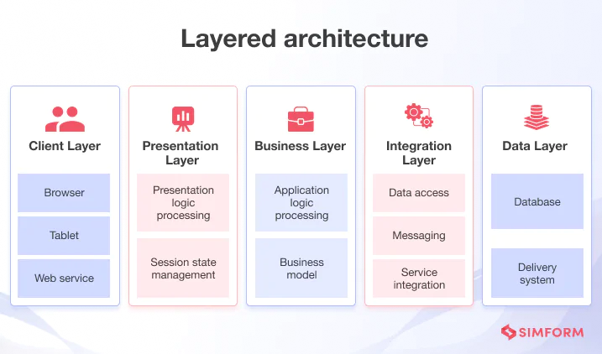

10. Explore different types of software environments (development, testing, production). Set up a basic environment in a virtual machine.
Ans:
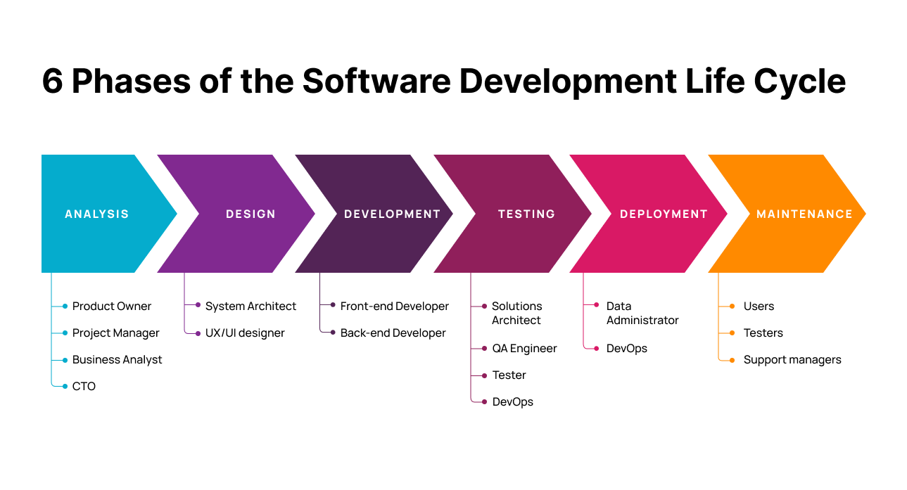
11. Create a flowchart representing the Software Development Life Cycle (SDLC).
Ans:
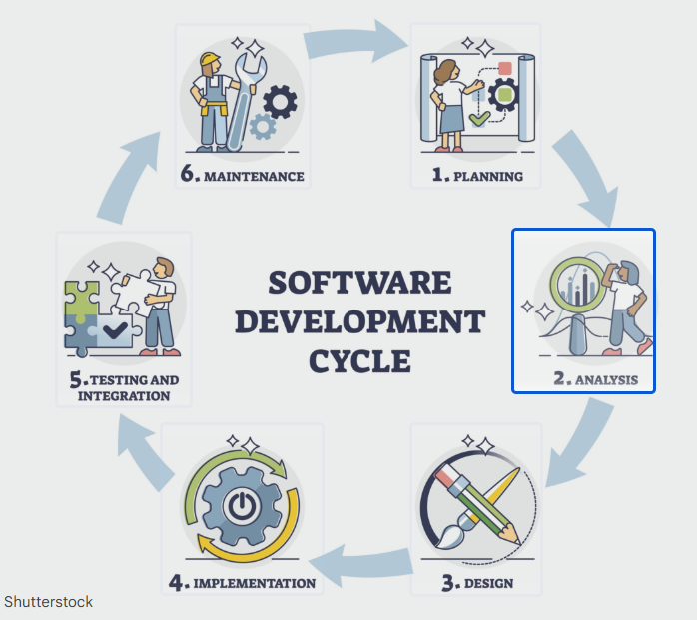

12. Write a requirement specification for a simple library management system.
Ans:
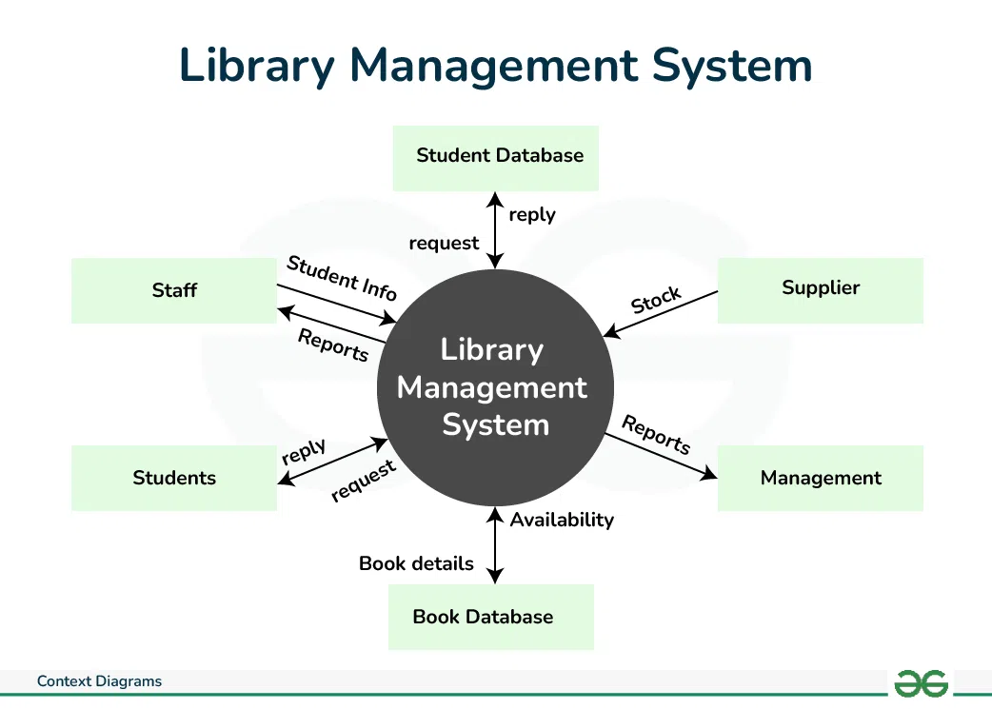

13. Perform a functional analysis for an online shopping system.
Ans:
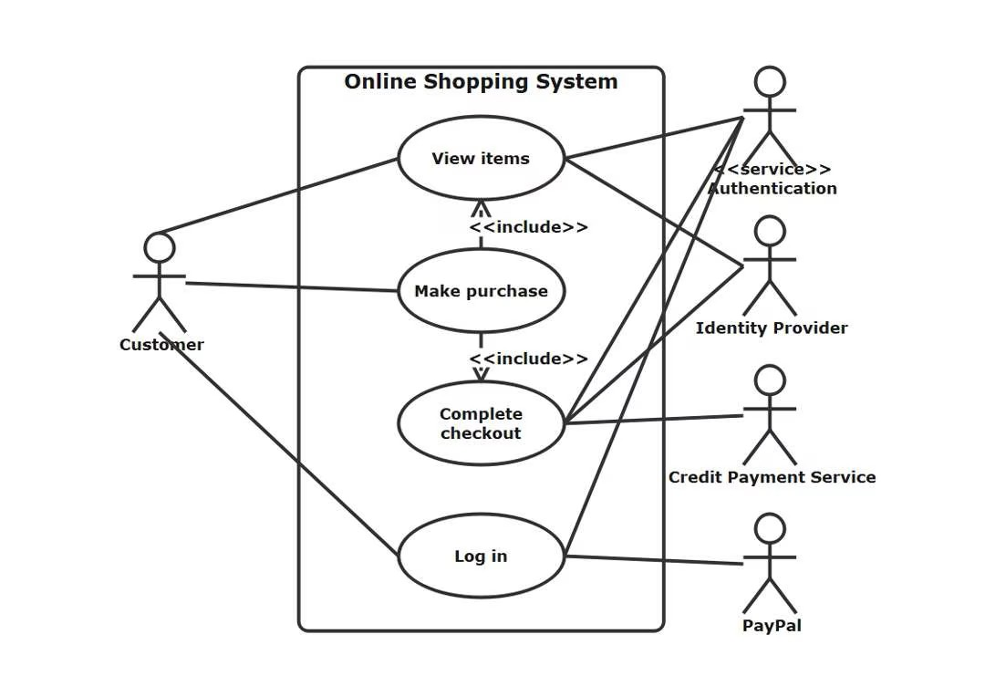
14. Design a basic system architecture for a food delivery app.
Ans:
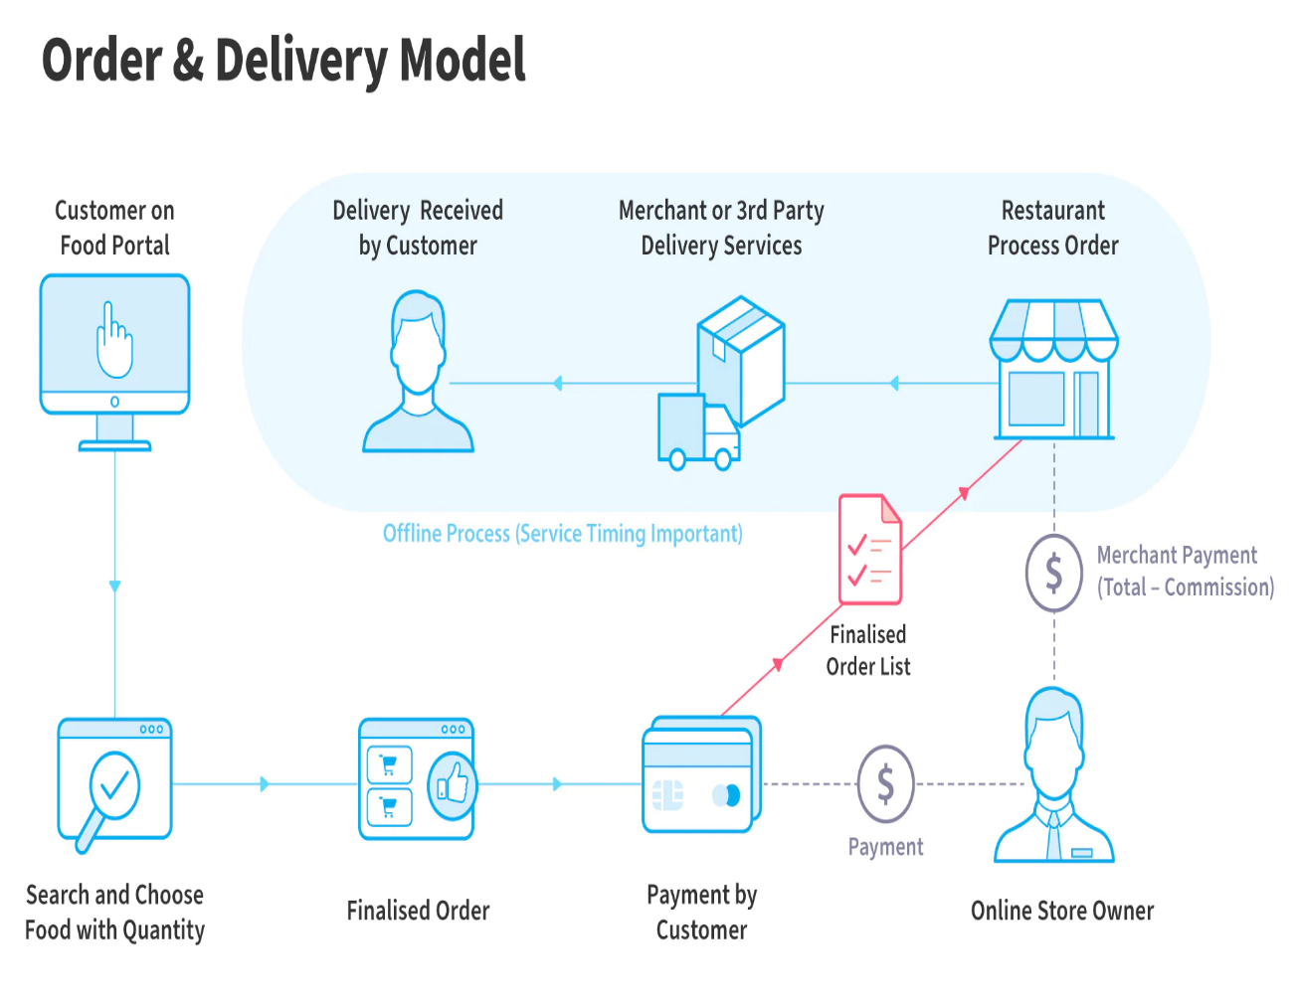

15. Draw a flowchart representing the logic of a basic online registration system.
Ans:
